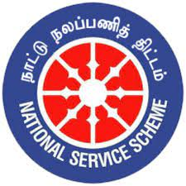
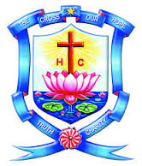
HOLY CROSS COLLEGE
(Autonomous)
Affiliated to Bharathidasan University
Nationally Accredited (4th Cycle) with A++ Grade (CGPA3.75/4) by NAAC
College with Potential for Excellence Tiruchirappalli – 620002, Tamil Nadu, India.

WOMEN’S STUDIES CENTRE
(FUNDED BY UGC)

&
NATIONAL SERVICE SCHEME

We cordially invite you for…

Date:11/12/2023 Time: 2 p.m. to 3 p.m
Venue: MCB Block Room No: 133
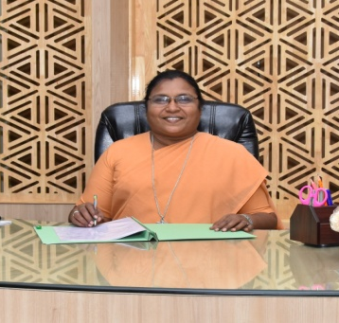
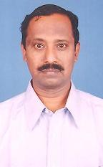
RESOURCE PERSON PRESIDED BY

Dr.S.Iyyamppllai
Former Senior Professor
Department of Economics
Bharathidasan University
Tiruchirappalli – 620 024.
Rev.(Sr.) Dr.Isabella Rajakumari
Principal
Holy Cross College (Autonomous)
Tiruchirappalli -620 002.

More Info
Organising Committee

Dr.F.Merlin Kokila, NSS Co-ordinator, HCC
Dr.P.Prisheela, WSC Co-ordinator, HCC
Dr.S.Elavarasi, Assistant Professor of Zoology, HCC

All are invited

